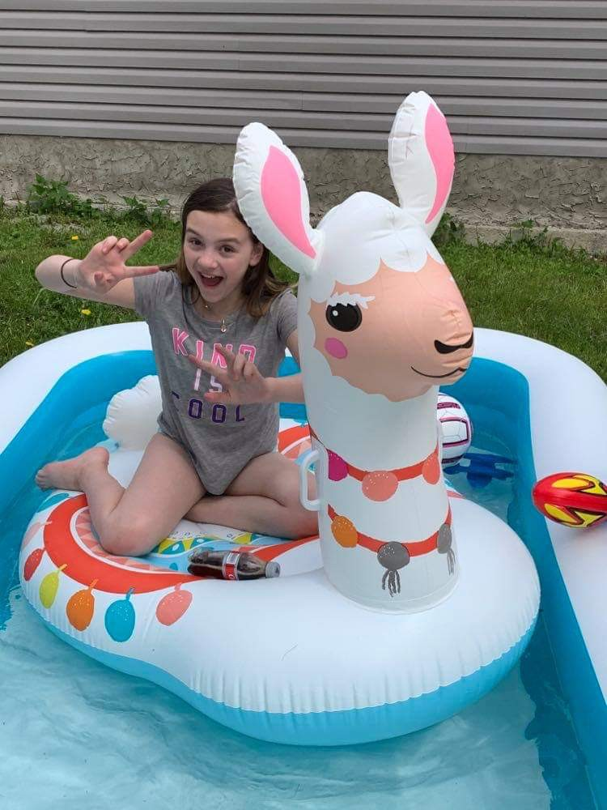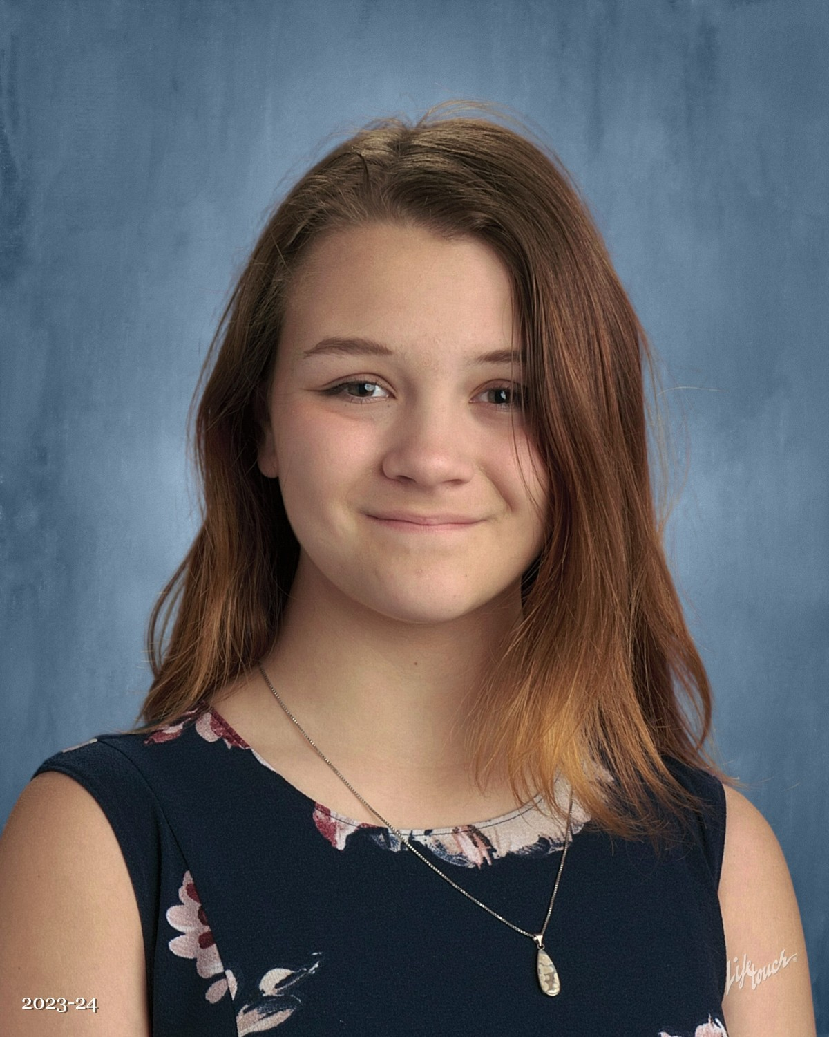

My name is Hailey Hiscock and I have an incredible story to tell. When I was 6 years old, I was diagnosed with Type 1 Diabetes. This diagnosis turned my whole family’s lives upside down. I was diagnosed before going into DKA (Diabetic Keto-Acidosis, Diabetic Coma), I was very lucky. I spent the first couple of years learning about my new life. When I was 9, I was switched from A Red Deer diabetes clinic to the Pediatric Diabetes Education Center in the Stollery Children’s Hospital.

During my first appointment we learned about a program where collecting and turning in pop tabs equated to a free/ cost effective insulin pump. My mom and my grandma spent the next incalculable amount of time collecting and counting tabs. At my next appointment we learned that our hard work was for naught. The program had been discontinued and there we sat with a huge collection from an amazing community. After some research we discovered that the Ronald McDonald House Charities were collecting tabs to provide necessary comforts and special additions for the families that needed to use the home.

My mom, my grandma and I scheduled a tour of the Edmonton RMHC home and were able to donate our enormous collection. Upon our tour I learned that each child that stays at the RMHC home receives a present of sorts. A toy, a book or something that just helps ease the pain of the current reality. I decided then that this effort is where I wanted to donate my tabs.

RMHC took the collection to the proper place and was given a certain amount per pound, and it all went towards the “Magic Room”. I am so happy that everything our community was able to collect went to keeping smiles on the faces of the children that needed it the most.

In my past few years, I have grown and changed and while my years of being able to use the RMHC for myself are quickly running out and I am so grateful to say that our years of collecting and helping haven’t. Right now, our collections have expanded throughout central and southern Alberta, with all proceeds going to the Magic Room but with a more specific purpose.

The love of reading and Art are absolute passions for me, and I want to be able to ensure that all children are able to embrace the same loves.

Now the RMHC no longer takes the tabs, instead my grandparents work tirelessly to advertise, collect and turn in all the tabs collected and donate every penny to RMHC across Alberta. I couldn’t be prouder then to be a part of such a meaningful endeavor and thank each and every person that spares their own time to make such an impact on so many deserving families.

For everything you do, Thank you!